

TRIBHUVAN UNIVERSITY
FACULTY OF HUMANITIES AND SOCIAL SCIENCES
A Project Report
On
“MovieMagic – “The streaming aspect for Cinematography”

Submitted to:
Department of Computer Application
National College of Computer Studies

In partial fulfillment of the requirements for the Bachelor’s Degree in Computer
Science and Information Technology

Submitted By:
Jenisha Sthapit (NCCSBCA083)
Rusha Manandhar (NCCSBCA096)
Under the Supervision of

Dinesh Khadka

Date: 28th Asar, 2081


Tribhuvan University
Faculty of Humanities and Social Sciences
National College of Computer Studies

SUPERVISOR’S RECOMMENDATION
I hereby recommend that this project prepared under my supervision by Jenisha Sthapit and Rusha Manandhar entitled MovieMagic – “The streaming aspect for Cinematography” in partial fulfillment of the requirements for the degree of Bachelor of Computer Application is recommended for the final evaluation.

……………………………….
SIGNATURE
Dinesh Khadka
SUPERVISOR
Faculty Member
Department of Computer Application
National College of Computer Studies

Tribhuvan University
Faculty of Humanities and Social Sciences National College of Computer Studies

LETTER OF APPROVAL

This is to certify that this project prepared by Jenisha Sthapit and Rusha Manandhar entitled MovieMagic – “The streaming aspect for Cinematography” in partial fulfillment of the requirements for the degree of Bachelor in Computer Application has been evaluated. In our opinion it is satisfactory in the scope and quality as a project for the required degree.

SIGNATURE of Supervisor  Dinesh Khadka  Faculty Member  Department of Computer Application National College of Computer Studies Paknajol, Kathmandu | SIGNATURE of HOD/ Coordinator  Rajan Poudel  Faculty Member  Department of Computer Application  National College of Computer Studies Paknajol, Kathmandu
SIGNATURE of Internal Examiner | SIGNATURE of External Examiner

ABSTRACT

Movies are a universal source of entertainment, yet many existing platforms are either too expensive or inaccessible to a broad audience. This project presents MovieMagic, a budget-friendly, high-quality movie streaming platform designed to bridge this gap. Developed using the waterfall methodology, the project followed a systematic approach encompassing planning, design, implementation, and rigorous testing to ensure a reliable and user-friendly product. The platform leverages a robust tech stack, including HTML, CSS, and JavaScript for the front end, and PHP and MySQL for backend operations, ensuring a seamless and secure user experience. MovieMagic features secure user authentication and a vast library of films, catering to diverse tastes and preferences. The project's success lies in its ability to provide an immersive, high-quality streaming experience, making premium entertainment accessible to a wider audience. In conclusion, MovieMagic stands out as a comprehensive solution for enjoyable movie streaming, combining technical excellence with user-centric design.

ACKNOWLEGDEMENT

The successful realization of our final year project owes much to the invaluable support extended by our project supervisors Mr. Dinesh Khadka, our designated supervisor, for his valuable guidance who gave us great encouragement for this work and helpful suggestions. We would also like to express our thanks to the National College of Computer Studies for providing us with an exceptional platform to pursue and develop this project.

Under the guidance of Mr. Dinesh Khadka and the NCCS team, our team has significantly deepened its understanding of movie streaming websites as well as various components associated with the development of this system. We extend our immense gratitude to the NCCS team for their thorough review, approval, and guidance throughout this transformative journey. We would also like to express our special thanks to Mr. Radha Krishna Gajurel , Mr.Nabaraj Negi and Mr. Chiranjibi Shrestha who guided us during the development of this project. Special acknowledgment is also due to the supportive online communities, as well as our friends and families, whose assistance was instrumental in the proper design, construction, and formation of this application.

In conclusion, we are truly honored by the collaborative efforts and support that have contributed to the success of our project.

Jenisha Sthapit

Rusha Manandhar

Date: 28/03/2081

.

Table of Contents

ABSTRACT i
ACKNOWLEGDEMENT ii
LIST OF ABBREVIATIONS iii
LIST OF FIGURES iv
LIST OF TABLES v
Chapter 1: Introduction 1
1.1 Introduction 1
1.2 Problem Statement 1
1.3 Objective 2
1.4 Scope and Limitation 2
1.5 Development Methodology 2
1.6 Report Organization 4
Chapter 2: Background Study and Literature Review 5
2.1 Background Study 5
2.2 Literature Review 5
Chapter 3: Requirement Analysis and Feasibility Study 7
3.1 System Analysis 7
3.1.1 Requirement Analysis 7
3.1.2 Feasibility Study 8
3.1.3 Analysis 9
Chapter 4: System Design 14
4.1 Design 14
4.1.1 Architectural Design 14
4.1.2 Interface design 16
4.1.3 Flowchart for Admin 18
4.1.4 Flowchart for User 20
4.1.5 Database design schema 21
Chapter 5: Implementation and Testing 25
5.1 Implementation 25
5.1.1 Tools Used 25
5.1.2 Implementation details of modules 26
5.2 Testing 33
Chapter 6: Conclusion and Future Improvements 36
6.1 Lesson learnt/outcome 36
6.2 Conclusion 36
6.3 Future Recommendations 36
References 38
Appendices 39

LIST OF ABBREVIATIONS

Apache | Server
CSS | Cascading Style Sheet
HTML | Hypertext Markup Language
MySql | Database Management System
PHP | PHP Hypertext Preprocessor
SQL | Structured Query Language

LIST OF FIGURES

Figure 1: Waterfall Model 3
Figure 2: Use case diagram for Admin and User 7
Figure 3: ER Diagram 9
Figure 4: Level-0 DFD Diagram 10
Figure 5: Level-1 DFD diagram 12
Figure 6: Architectural Design 14
Figure 7:Interface Design 16
Figure 8:Flow Diagram for Admin 18
Figure 9:Flowchart for User 20
Figure 10:Login Page 39
Figure 11:Homepage 1 39
Figure 12:Homepage 2 40
Figure 13:Dropdown option 40
Figure 14:Action Page 41
Figure 15:TV Shows Page 41
Figure 16:Watchlist 42

LIST OF TABLES
Table 1:about 21
Table 2:genre_info 21
Table 3:message 21
Table 4:moviedetails 22
Table 5:register 22
Table 6:reviews 22
Table 7:service 23
Table 8:watchlist 23

Chapter 1: Introduction

1.1 Introduction
Movies are an enchanting escape, weaving captivating narratives and visual spectacles that transport audiences into diverse worlds. The silver screen's glow illuminates storytelling at its finest, offering a powerful medium to evoke emotions and create lasting memories. From gripping dramas to heartwarming comedies, movies captivate, entertain, and leave an indelible mark on our cinematic journey.
Introducing MovieMagic, your cinematic companion offering a unique blend of affordability and quality entertainment. Embracing a low-budget ethos, MovieMagic ensures that the magic of movies remains accessible to all. Experience the thrill of cinematic storytelling without breaking the bank. MovieMagic boasts an impressive collection of high-definition movies, ensuring a visually stunning and immersive viewing experience. This user-friendly platform not only values your budget but also your time, delivering an array of genres and timeless classics at your fingertips. With MovieMagic, enjoy the best of both worlds – low-cost accessibility and top-notch cinematic quality, redefining the way you experience movies online.

1.2 Problem Statement
In today's rapidly evolving digital entertainment landscape, existing movie streaming platforms often fall short in providing a seamless and personalized user experience. This project aims to develop an online movie streaming platform designed to provide users with convenient access to a vast library of movies from the comfort of their homes. With this platform, users can enjoy a seamless movie-watching experience on their computers or mobile devices, without the need to visit crowded cinemas or wait for DVDs. All that is required is an internet connection and a device to access the platform. Users will need to create an account using their email and a secure password to log in and explore the movie collection. The platform ensures that login credentials are protected with high-level encryption, guaranteeing the security of users' personal information and access to their personalized watchlist and recommendations.

1.3 Objective

The main objective of this project is:
- To develop a web application with a seamless experience for browsing, viewing, and managing their movie collections and preferences on a user-friendly platform.

1.4 Scope and Limitation

The scope of the MovieMagic movie streaming platform includes providing users with a seamless viewing experience via a user-friendly interface, comprehensive movie catalog management, personalized watchlists, and smooth playback.

However, limitations such as content availability constraints, technical complexities, internet connectivity issues, privacy concerns, scalability challenges, and the need for user adoption promotion remain. Addressing these limitations is crucial for the platform's success.

1.5 Development Methodology

In this project waterfall method has been used as the development methodology. The waterfall model is a sequential software development process where progress flows steadily downwards (like a waterfall) through several phases. Each phase must be completed before moving on to the next, with minimal to no overlap between phases. The waterfall model in this project follows the following phases:

Requirement gathering
- Gather and document detailed requirements for the movie streaming platform.
- Define the range of features, content types (movies, TV shows, etc.), performance expectations (streaming quality, speed), and user interface preferences (search functionality, user profiles).

System design
- Design the overall architecture of the movie streaming platform.
- Create design documents specifying the user interface layout, content management system, and streaming capabilities.
- Develop data flow diagrams to illustrate how data will move through the system.
- Design an Entity-Relationship (ER) diagram to model the database structure, including relationships between different data entities.

Implementation
- Write code for the entire platform based on the design specifications.
- Develop the front-end components for user interaction (streaming interface, user profiles).
- Implement the back-end components for server-side logic (content management, user authentication).
- Create the database schema for storing movies, user data, and transaction records.
- Integrate the front-end, back-end, and database components to form a complete system

Testing
- Conduct unit testing for individual components such as user login, movie playback, and database operations.
- Perform integration testing to ensure that all system components work together seamlessly (e.g., user authentication integrates with content delivery).
- Execute system testing to verify overall system functionality and user scenarios (searching for movies, creating playlists)
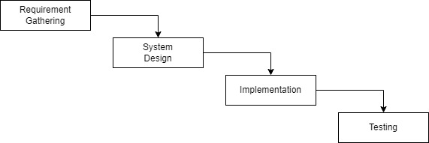
Figure 1: Waterfall Model

1.6 Report Organization

We have organized out report in the following way:

Chapter 1: It includes the introduction section, the problem we attempted to solve, and the objectives and scope, development methodology for the project.

Chapter 2: It includes the background study of fundamental theories, general concepts and literature review of similar projects, theories and results by other researchers.

Chapter 3: It provides an overview of all the requirements along with system analysis and feasibility analysis of the system.

Chapter 4: It includes a detailed description of how the system was designed.

Chapter 5: It includes the tools we used to build the system and how the testing process was done.

Chapter 6: It includes the conclusion of the project and how we are further planning to make the system work sustainably.

Chapter 2: Background Study and Literature Review

2.1 Background Study

The rapid evolution of digital technology has significantly transformed the entertainment industry, particularly in how movies are distributed and consumed. Traditional movie theaters and physical media such as DVDs are increasingly being replaced by online streaming platforms that offer convenience, a broad range of content, and personalized user experiences. The advent of high-speed internet, advancements in streaming technology, and the proliferation of smart devices have enabled users to access vast libraries of movies and TV shows from the comfort of their homes.

The growth of the online streaming market has been driven by major players like Netflix, Amazon Prime Video, and Hulu, which have set high standards for content quality, user interface, and customer satisfaction. However, there remains a demand for more affordable streaming options that do not compromise on quality.

2.2 Literature Review

Digital Entertainment and Streaming Platforms: The shift towards digital entertainment has been widely studied. In their research, A. Smith and P. Anderson [1] discuss the impact of streaming technology on consumer behavior and the decline of traditional media. They highlight that accessibility, convenience, and personalized recommendations are key factors driving the adoption of streaming services.

Another study by M. Kumar and S. Sharma [2] explores the economic and technical challenges faced by new entrants in the streaming market. They emphasize the importance of a robust content library, user-friendly interface, and reliable streaming technology to compete with established players.

User Experience in Streaming Services: User experience (UX) plays a crucial role in the success of streaming platforms. According to a study by L. Johnson and K. Williams [3], intuitive navigation, seamless playback, and personalized recommendations significantly enhance user satisfaction. Their research also points out that buffering issues and complicated interfaces are major deterrents for users.

Waterfall Methodology in Software Development: The waterfall model is a traditional approach to software development, characterized by its linear and sequential process. According to B. Boehm [4], this methodology is beneficial for projects with well-defined requirements and where changes are minimal. However, it may not be as flexible as iterative models like Agile, which can adapt to evolving requirements.

Comparative Analysis of Streaming Platforms: A comparative analysis by D. White and E. Black [5] of various streaming platforms shows that while high-budget platforms like Netflix offer extensive content libraries and advanced features, there is a significant market for affordable platforms that provide essential streaming services without high subscription fees.

Chapter 3: Requirement Analysis and Feasibility Study

3.1 System Analysis

3.1.1 Requirement Analysis

The goal of the requirement analysis process for this project was to determine the essential functions and features of the system as well as any restrictions or limits that would need to be taken into account when it was being developed.

3.1.1.1 Functional Requirement
The movie streaming platform must include a robust content collection with search and filtering features, safe user authentication, and efficient video playback management. The system can only be accessed by the admin. Movies and information can be added, removed, or edited by the admin. Movies may be streamed and browsed online. Additionally, users may choose which movies to watch from a variety of genres and categories.

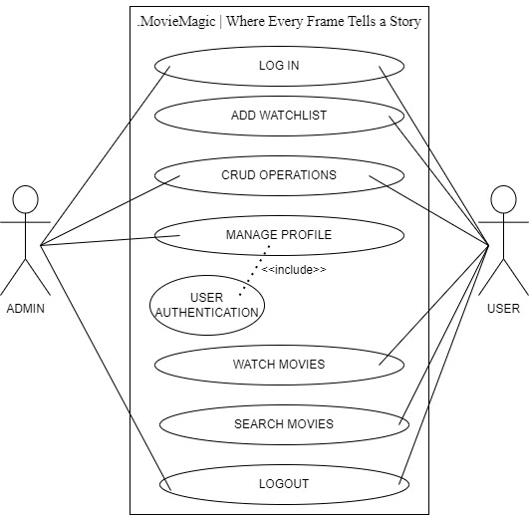
Figure 2: Use case diagram for Admin and User

3.1.1.2 Non-functional Requirement
The non-functional requirements for the movie streaming platform focus on ensuring reliability, performance, and security. The platform should provide high availability and fault tolerance to minimize downtime and ensure continuous access to content. Performance metrics include fast load times and seamless video playback with minimal buffering, supported by a scalable infrastructure to handle varying levels of user traffic and large volumes of video data. The system must also be maintainable and extendable, allowing for future upgrades and the integration of new features without significant disruption.

3.1.2 Feasibility Study
The feasibility study assesses the system's functionality under specific constraints, evaluating how viable it is to develop the system under these conditions. The key feasibility aspects considered include operational, economic, and technical feasibility.

3.1.2.1 Technical Feasibility
The system demonstrates strong technical feasibility by leveraging well-established technologies such as HTML, CSS, JavaScript, PHP, and MySQL. These technologies are widely supported and have extensive documentation, making them reliable choices for building robust web applications. Additionally, the system's hardware requirements are modest, requiring only standard computing equipment, ensuring compatibility and scalability without significant hardware upgrades.

3.1.2.2 Operational Feasibility
Operational feasibility is ensured as the system prioritizes user-friendly design principles, offering an intuitive interface that enhances user experience. The system's responsiveness across various devices ensures accessibility and usability, contributing to its operational feasibility. By focusing on simplicity and efficiency in its design, the system minimizes training needs and facilitates seamless integration into existing workflows, thereby enhancing operational efficiency.

3.1.2.3 Economic Feasibility
Economic feasibility is a strong suit of the system, requiring minimal resources for deployment and operation. The primary resources needed are a standard laptop and a reliable internet connection, which are readily available and cost-effective. The system's cost-effectiveness is further bolstered by leveraging open-source technologies and avoiding costly proprietary software licenses. With streamlined operational costs and low initial investment requirements, the system presents a financially viable solution that aligns with budgetary constraints and ensures sustainable long-term operation.

3.1.3 Analysis

3.1.3.1 Data Modeling

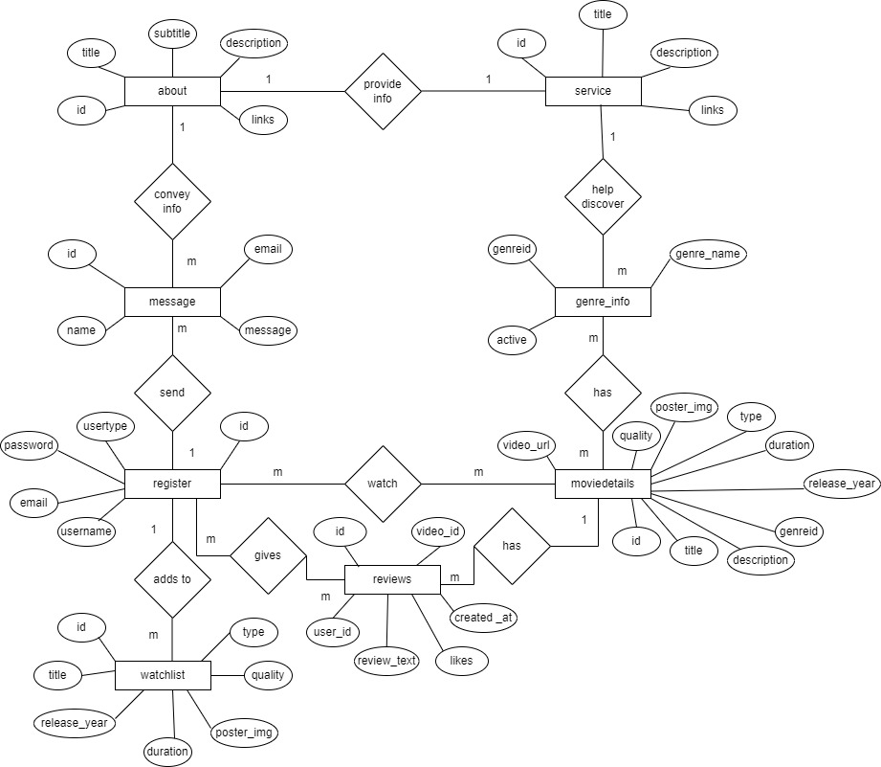
Figure 3: ER Diagram

Entities:

The ER diagram represents a movie database with the following entities:
- Register: Represents a user or an admin based on the usertype.
- MovieDetails: Represents a movie with information like title, description, genre, etc.
- Message: Represents a message sent by users.
- Watchlist: Represents a list of movies a user wants to watch.
- Reviews: Represents user reviews of a movie.
- About: Represents information about the platform.
- Genre_info:Probides information about the genre.

3.1.3.2 Process Modeling

DFD Diagram

DFD Level 0

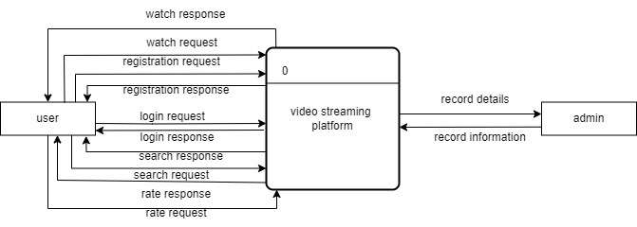
Figure 4: Level-0 DFD Diagram

The context diagram provides a top-level view of how the system interacts with its environment and the data it processes. It does not go into the details of internal processes; instead, it focuses on the high-level relationships between the system and external entities. It interacts with the user as:
- From Users to System: login credentials, registration information, search queries, streaming requests.
- From System to Users: streamed content, user account information.

DFD Level 1

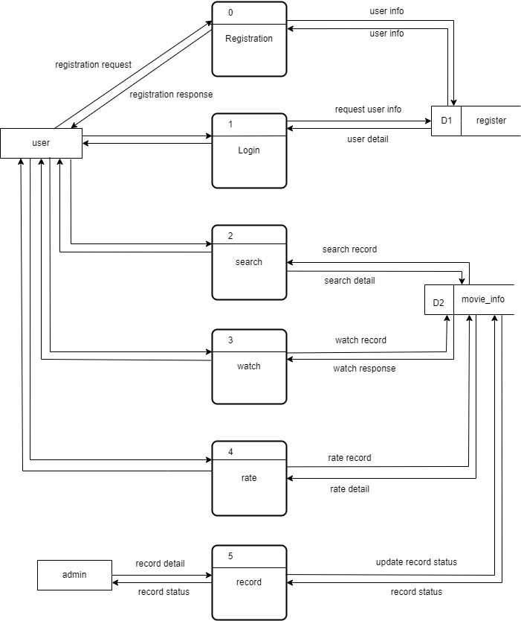
Figure 5: Level-1 DFD diagram

This Level 1 DFD provides an overview of how different processes interact with data stores and external entities. It outlines the flow of data within the system and the basic functionality of the various processes.
- Process: User Management
- Register User: Collects user information (username, password, email) and saves it in the user Database.
- Login User: Authenticates user credentials from the User Database and grants access.
- Process: Streaming Service
- Stream Movie: Streams requested movies to users.
- Data Stores
- User Database: Stores user registration and login data.
- Movie Database: Stores movie information including titles, descriptions, genres, and streaming links.

External Entities:
- Users:
- Provide registration information, login credentials, and movie requests.
- Receive streamed movies, movie information.
- Admin:
- Provides new movie data, updated movie data, and delete requests.
- Receives success or error messages for movie creation, updates, and deletions.

Chapter 4: System Design

4.1 Design
The movie streaming platform has a user-friendly style that makes it simple to navigate on desktop and mobile devices. Its easy-to-use movie and TV program classification improves user accessibility. A visually appealing content collection with effective search and filtering features is part of the UI. Simple controls and a simplified viewing experience guarantee fluid playback. Personalized suggestions and convenient access to stored material are made possible by user profiles. A secure and seamless user experience is ensured by consistent branding and strong security measures that safeguard user data and transactions.

4.1.1 Architectural Design

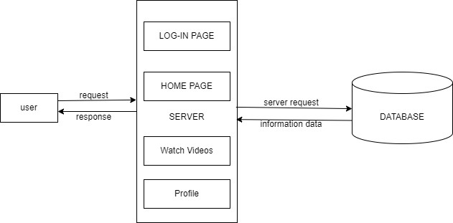
Figure 6: Architectural Design

An architectural diagram for movie streaming website provides an overview of the system's structure, including its major components, their interactions, and how data flows between them. This kind of diagram helps you understand how the different parts of the system work together to achieve the desired functionality.

Key components:
- Client Interfaces:
- Web Interface:

A frontend application that allows users to interact with the system, such as browsing movies, registering, logging in, and streaming movies.
- Server Components:
- Web Server:

Handles incoming HTTP requests from clients and serves static content.
- Application Server:

Hosts the backend logic of the application, handling requests from clients and interacting with databases and other external services.
- Data Stores:
- User Database:

Stores user data, such as registration details, login credentials, and profile information.
- Movie Database:

Stores movie data, such as titles, descriptions, genres, and streaming URLs.
- Interactions and Data Flow:
- User Interactions:

Users interact with the system through the web interface. They can browse movies, register, log in, and stream content.
- Server Interactions:

The web server and application server handle requests and responses from clients, routing requests to the appropriate backend services.
- Database Interactions:

The application server interacts with the user and movie databases to create, read, update, and delete data as required by user and admin actions.

4.1.2 Interface design

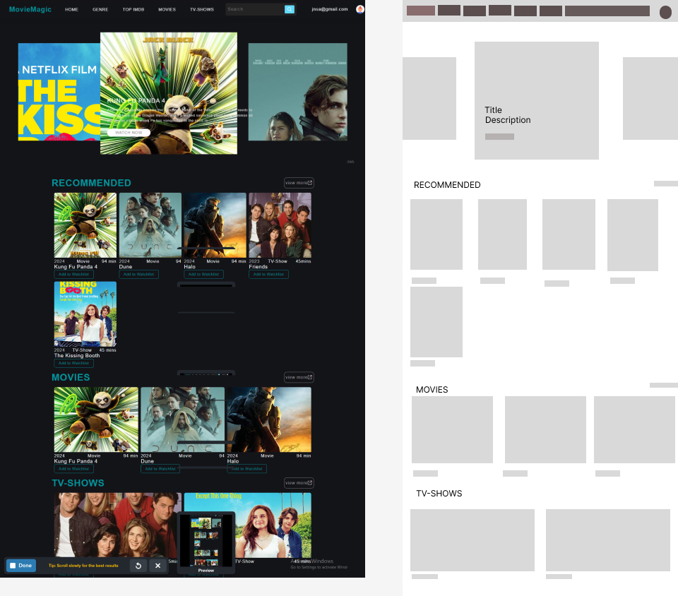
Figure 7:Interface Design

Header
- Logo and Branding: The logo "MovieMagic" is placed on the top-left corner.
- Navigation Menu: Key sections like "Home," "Genre," "Top IMDB," "Movies," and "TV Shows" are prominently displayed, providing easy navigation.
- Search Bar: A search bar is located centrally, enabling users to quickly find specific content.
- User Profile: The top-right corner features the user’s email, indicating the logged-in status.

Main Content Area
- Featured Section: The top portion showcases a large banner area with featured content. It highlights the latest and most popular movies or TV shows to catch the user's attention. For instance, "The Kissing Booth" and "Kung Fu Panda 4" are prominently displayed.
- Recommended Section: Below the featured content, a "Recommended" section displays suggested movies and TV shows tailored to the user’s preferences. Each item includes a thumbnail, title, duration, type (movie or TV show), and options to add to the watchlist.
- Movies Section: This section lists movies, allowing users to scroll through the latest or popular movies available on the platform. Thumbnails are used to attractively display each movie with its title and duration.
- TV Shows Section: Similar to the movies section, this area features TV shows. It includes thumbnails, titles, and episode durations to help users quickly identify and select content.

Design Elements
- Consistent Layout: The design uses a grid layout for organized and consistent presentation. Each section is clearly demarcated, making it easy for users to browse content.
- Dark Theme: A dark color scheme is used, which is common for streaming platforms to enhance visual appeal and reduce eye strain during prolonged viewing.
- Interactive Elements: Buttons like "Add to Watchlist" and "View More" offer interactivity, encouraging user engagement with the content.

Wireframe
- The wireframe on the right side provides a structural overview, showing the planned layout without design elements. It outlines where each section and content type will be placed, aiding in the development process by ensuring all elements are accounted for before the final design.

4.1.3 Flowchart for Admin

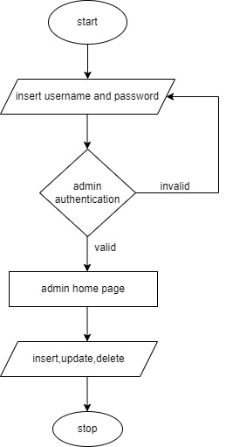
Figure 8:Flow Diagram for Admin

Main processes and interactions of an admin:
- Admin Authentication:
- Admin navigates to the admin login page.
- Admin enters login credentials (username and password).
- System verifies the credentials.
- If credentials are valid, admin is granted access to the admin panel.
- Admin Panel:
- After successful authentication, admin lands on the admin panel dashboard.
- Manage:

In this section, admin can perform the following actions:
- Insert Movie, Tv-shows:
- Admin can add a new movie by providing details such as title, genre, cast, synopsis, release date, etc.
- Admin can upload link to the movie.
- Update Movie, Tv-shows:
- Admin can modify details such as title, genre, cast, synopsis, release date, etc.
- Admin can update the link if needed.
- Delete Movie:
- Admin can search for a specific movie by title or ID.
- Once a movie is selected, admin can delete the movie from the database.
- Logout:
- Admin can log out of the admin panel.

4.1.4 Flowchart for User

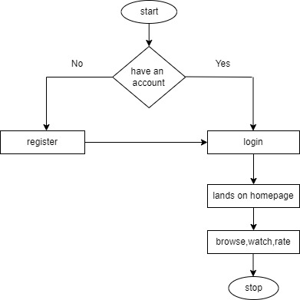
Figure 9:Flowchart for User

Main processes and interactions of a user:
- User Registration/Login:
  - User navigates to the website.
  - User can either register for a new account or log in with existing credentials.
- Homepage:
- After logging in, user lands on the homepage.
- The homepage displays featured movies, categories, and recommendations.
- Browse Movies:
- User can browse movies by category, genre, release year, etc.
- User can also search for specific movies using the search bar.
- Movie Details:
- When the user clicks on a movie, they are directed to the movie details page.
- This page displays information about the movie such as synopsis, cast, ratings, etc.
- Watch Movie:
- If the user decides to watch the movie, they click on the play button.
- Logout:
- User can log out from the website.

4.1.5 Database design schema

Table 1:about
id | int(20)AUTO_INCREMENT PRIMARY KEY
title | varchar(50)
subtitle | varchar(50)
description | Longtext
links | varchar(100)

Table 2:genre_info
Genreid | int(11)AUTO_INCREMENT PRIMARY KEY
genre_name | varchar(50)
Active | int(4)

Table 3:message
id | int(11)AUTO_INCREMENT PRIMARY KEY
name | varchar(50)
email | varchar(150)
message | Longtext

Table 4:moviedetails
id | int(11) AUTO_INCREMENT PRIMARY KEY
title | varchar(191)
description | Longtext
genreid | int(11)
release_year | int(11)
duration | varchar(30)
type | varchar(30)
poster_img | varchar(191)
quality | Mediumtext
video_url | varchar(255)

Table 5:register
id | int(11)AUTO_INCREMENT PRIMARY KEY
username | varchar(50)
email | varchar(150)
password | varchar(50)
usertype | varchar(20)

Table 6:reviews
id | int(11) AUTO_INCREMENT PRIMARY KEY
video_id | int(11)
user_id | int(11)
review_text | Text
likes | int(11)
created_at | Timestamp

Table 7:service

id | int(20) AUTO_INCREMENT PRIMARY KEY
title | varchar(50)
description | Longtext
links | varchar(100)

Table 8:watchlist
id | int(11) AUTO_INCREMENT PRIMARY KEY
title | varchar(50)
release_year | int(11)
duration | varchar(30)
poster_img | varchar(191)
quality | Mediumtext
type | varchar(5)

Here's a brief explanation of some of the terms in the context:
subtitle, title, description, links, about, id, name, message, send, usertype, register, password, username,email, genreid, genre_name, genre_info, active, has, watch, moviedetails, URL, quality, poster_img, release_year, type, duration
These terms are common in movie or TV show databases and refer to various attributes associated with a movie or TV show.
- subtitle: Subtitles available for the movie or TV show.
- title: The name of the movie or TV show.
- description: A brief summary of the movie or TV show's plot.
- links: Any external links related to the movie or TV show, such as its official website or social media pages.
- about: Additional information about the movie or TV show.
- id: A unique identifier for the movie or TV show.
- name: The name of the user or entity associated with the movie or TV show.
- message: A message related to the movie or TV show.
- send: The action of sending a message or request related to the movie or TV show.
- usertype: The type of user account, such as a free or premium user.
- register: The action of registering for a user account.
- password: The secret code used to authenticate a user account.
- username: A unique name used to identify a user account.
- email: The user's email address.
- genreid: A unique identifier for the genre of the movie or TV show.
- genre_name: The name of the genre of the movie or TV show.
- genre_info: Additional information about the genre of the movie or TV show.
- active: A flag indicating whether the movie or TV show is currently available.
- has: A flag indicating whether the user has access to the movie or TV show.
- watch: The action of watching the movie or TV show.
- moviedetails: Detailed information about the movie or TV show.
- video_url: The web address of the movie or TV show's page.
- quality: The video quality of the movie or TV show.
- poster_img: The image used to represent the movie or TV show.
- release_year: The year the movie or TV show was released.
- type: The type of media, such as a movie or TV show.
- duration: The length of the movie or TV show.

Chapter 5: Implementation and Testing

5.1 Implementation
The waterfall model is applied to develop a movie streaming platform through a systematic, sequential approach. It begins with gathering comprehensive requirements from stakeholders and users, detailing functionalities like content categorization, playback quality, and user interface design. With these requirements in hand, the platform's architecture is meticulously designed, encompassing frontend layout, backend infrastructure for data storage, and scalability considerations for future growth. Development follows, where software engineers write code and integrate necessary components, ensuring each phase is completed before moving to the next. Rigorous testing is then conducted to verify functionality and performance, ensuring seamless user experience and reliability in streaming services. Once tested and approved, the platform is deployed, and ongoing maintenance ensures it meets user expectations while adhering to security standards and evolving industry trends.

5.1.1 Tools Used

For our movie streaming platform project, a combination of essential tools and technologies is employed across various development phases:

Frontend:
- HTML: Utilized to structure and define the content and layout of web pages, including movie listings, user profiles, and streaming interfaces.
- CSS: Used for styling and enhancing the visual presentation of the platform, ensuring a cohesive and user-friendly design.
- JavaScript (JS): Implements interactive features and dynamic content updates, enhancing user engagement and functionality across different devices.

Backend:
- PHP: Powers server-side operations and dynamic content generation, handling user authentication, session management, and database interactions.

Database:
- MySQL: Serves as the database management system to store and manage movie metadata, user data, and transactional information efficiently.

Development Environment:
- Visual Studio Code (VSCode): Chosen as the primary integrated development environment (IDE) for coding frontend and backend components. VSCode provides robust editing capabilities, debugging tools, and extensions for seamless workflow management and collaboration.

By leveraging these tools effectively, MovieMagic aims to deliver a responsive, secure, and feature-rich experience for users, ensuring efficient data management and seamless interaction across different devices and platforms.

5.1.2 Implementation details of modules
The different modules provided are:

Module 1: Browse Movies
It provides an interface for users to browse available movies across various genres and categories.
Features:
- Users can view movie details, including titles, descriptions, genres, and ratings.
- Allows users to sort and filter movies based on different criteria (e.g., release date, popularity, genre).
- Displays thumbnails or posters for each movie to aid in visual browsing.
Module 2: Stream Movies
It enables users to stream selected movies directly on their devices.
Features:
- Users can select a movie to watch from the list of available options.
- Provides playback controls such as play, pause, and volume adjustments.
Module 3: Admin Manage Movies
It allows the admin to manage the movie database, including adding, updating, and deleting movies.
Features:
- Admin can add new movies, including their metadata (titles, descriptions, genres, release dates, etc.).
- Admin can update existing movies, such as modifying descriptions or genres.
- Admin can delete movies from the database as needed.
Add:
<table class="table table-bordered" id="dataTable" with="100%" cellspacing="0">
<thead>
<tr>
<th>ID</th>
<th>TITLE</th>
<th>RELEASE YEAR</th>
<th>DURATION</th>
<th>IMAGE</th>
<th>EDIT</th>
<th>DELETE</th>
</tr>
</thead>
<tbody>
<?php
if(mysqli_num_rows($result)>0)
{
while($row=mysqli_fetch_assoc($result))
{
?>

<tr>
<td><?php echo $row['id']; ?></td>
<td><?php echo $row['title']; ?></td>
<td><?php echo $row['release_year']; ?></td>
<td><?php echo $row['duration']; ?></td>
<td><?php echo '<img src="upload/'.$row['poster_img'].'" width="100px;" height="100px;" alt="Movie Poster">'?></td>
<td>
<form action="moviedetails.php" method="POST">
<input type="hidden" name="edit_id" value="<?php echo $row['id']; ?>">
<button type="submit" name="edit_btn" class="btn btn-success">EDIT</button>
</form>
</td>
<td>
<form action="code.php" method="POST">
<input type="hidden" name="delete_id" value="<?php echo $row['id']; ?>">
<button type="submit" name="movie_delete_btn" class="btn btn-danger">DELETE</button>
</form>
</td>
</tr>
<?php
}
}
else
{
echo "No Records Found!";
}
?>
</tbody>
</table>
Update:
div class="container-fluid">
<div class="card shadow mb-4">
<div class="card-header py-3">
<h6 class="m-0 font-weight-bold text-primary">Edit Movie Details</h6>
</div>
<div class="card-body">
<?php
if (!$connection) {
die("Database connection failed: " . mysqli_connect_error());
}

if (isset($_POST['edit_btn'])) {
$id = $_POST['edit_id'];
$query = "SELECT * FROM moviedetails WHERE id='$id'";
$result = mysqli_query($connection, $query);

if (!$result) {
die("Query failed: " . mysqli_error($connection));
}

// Check if any row is fetched
if (mysqli_num_rows($result) > 0) {
$row = mysqli_fetch_assoc($result);
$current_genre = $row['genreid'];
$current_image = $row['poster_img'];
?>
<form action="code.php" method="POST" enctype="multipart/form-data">
<input type="hidden" name="edit_id" value="<?php echo $row['id']; ?>">

<div class="form-group">
<label>Title</label>
<input type="text" name="m_title" class="form-control" placeholder="Enter Movie Title" value="<?php echo $row['title']; ?>">
</div>
<div class="form-group">
<label> Description</label>
<textarea name="description" class="form-control" required rows="3"><?= $row['description']; ?></textarea>
</div>
<div class="form-group">
<label>Genre</label>
<select name="gid" class="form-control">
<?php
$sql = "SELECT * FROM genre_info WHERE active='1'";
$res = mysqli_query($connection, $sql);
$count = mysqli_num_rows($res);
if($count>0)
{
while($col=mysqli_fetch_assoc($res))
{
$genre_title = $col['genre_name'];
$genreid = $col['genreid'];
?>

<option
<?php if($current_genre == $genreid) {echo "selected";} ?> value="<?php echo $genreid; ?>">
<?php echo $genre_title; ?>
</option>

<?php
}
}
else
{
echo "<option value='0'>Category Not Available</option>";
}

?>
</select>
</div>
<div class="form-group">
<label>Release Year</label>

<input type="text" name="m_year" class="form-control" placeholder="Enter Released Year" value="<?php echo $row['release_year']; ?>">
</div>
<div class="form-group">
<label>Duration</label>
<input type="text" name="m_duration" class="form-control" placeholder="Enter Duration" value="<?php echo $row['duration'] ?? ''; ?>">
</div>
<div class="form-group">
<label>Type</label>
<input type="text" name="m_type" class="form-control" placeholder="Enter Type" value="<?php echo $row['type'] ?? ''; ?>">
</div>
<div class="form-group">
<label> Current Poster Image</label><br>
<td>
<!-- Display image if available -->
<?php
if($current_image == "")
{
echo "<h6>Image not Available</h6>";
}
else
{
echo '<img src="upload/'.$row['poster_img'].'" width="100px;" height="100px;" alt="Movie Poster">';
}
?>
</td>
</div>
<div class="form-group">
<label> New Poster</label>
<input type="file" name="m_img" id="m_img" class="form-control" placeholder="Insert Image">
</div>
<div class="form-group">
<label>Quality</label>
<input type="text" name="m_quality" class="form-control" placeholder="Enter Duration" value="<?php echo $row['quality'] ?? ''; ?>">
</div>
<a href="movie_info.php" class="btn btn-danger">CANCEL</a>
<button type="submit" name="updatebtn" class="btn btn-primary">Update</button>
</form>
<?php
} else {
echo "No data found for ID: " . $id;
}
}
?>
</div>
</div>
</div>

5.2 Testing

Table 5.2.1: Test Cases of Unit Testing for Admin Operation
Test Case(s) | Steps | Expected Results | Status
1. Login as an admin | The user logs in as an admin. | The user should be redirected to the admin dashboard. | Pass
 | The user logs in with incorrect credentials. | The user should see an error message and not be redirected. | Fail
2. Add new movie | Admin fills in all required fields for a new movie. | The movie should be added to the database, and the admin should be redirected to the dashboard. | Pass
3.View movies | Admin clicks on the "View Movies" button. | Admin should see a list of all movies in the database. | Pass
4. Update a movie | Admin selects a movie to update and fills in new details. | The movie should be updated in the database. | Pass
 | Admin fills in incorrect details for update. | The admin should see a validation error message and the movie should not be updated. | Fail
5. Delete a movie | Admin selects a movie to delete. | The movie should be removed from the database. | Pass
6. View users | Admin clicks on the "View Users" button. | Admin should see a list of all users in the database. | Pass
 | Database connection error occurs. | Admin should see an error message indicating the database is unavailable. | Fail
7. Update a user | Admin selects a user to update and fills in new details. | The user should be updated in the database. | Pass
 | Admin fills in incorrect details for update. | The admin should see a validation error message and the user should not be updated. | Fail
8. Delete a user | Admin selects a user to delete. | The user should be removed from the database. | Pass

Table 4.2: Test Cases of System Testing
Test Case(s) | Steps | Expected Results | Status
1. Browse movies | User views the list of available movies. | User should see a list of available movies with titles, genres, and thumbnails. | Pass
 | Database connection error occurs. | User should see an error message indicating the database is unavailable. | Fail
2. Select a movie | User selects a movie from the list. | User should be able to see detailed information about the movie (description, rating, etc.). | Pass
 | User selects a movie but detailed information fails to load. | User should see an error message indicating the movie details are unavailable. | Fail
3. Stream a movie | User chooses to stream a movie. | The movie should start streaming without buffering issues. | Pass
4. Add to watchlist | User adds a movie to their watchlist. | The movie should be added to the user's watchlist and visible there. | Pass
 | Database update error occurs. | User should see an error message indicating the movie could not be added to the watchlist. | Fail
5. View watchlist | User navigates to the "Watchlist" section. | User should see a list of movies they have added to their watchlist. | Pass
 | Database update error occurs. | User should see an error message indicating the watchlist is unavailable. | Fail
6. Search for movies | User searches for movies by title, genre, or actor. | User should see a list of movies that match their search criteria. | Pass
 | User searches for movies but no results match the criteria. | User should see a message indicating no movies were found. | Fail
7. Review a movie | User writes a review for a movie they watched. | The user's review should be saved in the database and visible to other users. | Pass
 | Database update error occurs. | User should see an error message indicating the review could not be saved. | Fail

Top of Form
Bottom of Form

Chapter 6: Conclusion and Future Improvements

6.1 Lesson learnt/outcome
The development of the MovieMagic project has been a significant journey marked by both challenges and achievements. The project successfully delivered an online movie streaming platform that prioritizes user experience. Throughout its development, valuable lessons were learned about the importance of meticulous planning, effective communication. Overcoming obstacles such as integrating databases and ensuring seamless playback demonstrated the team's resilience and problem-solving abilities. By adhering to rigorous testing and quality assurance protocols, MovieMagic ensured a robust and reliable platform for users to enjoy their favorite movies. The project's success underscores the importance of collaboration, technical expertise, and a user-centric approach in achieving project goals.

6.2 Conclusion

The MovieMagic project aimed to deliver an affordable, high-quality online movie streaming platform, successfully addressing the identified gaps in the digital entertainment landscape. By embracing a low-budget ethos, MovieMagic ensures accessibility for all users, without compromising on the quality of the cinematic experience. The platform's user-friendly interface, comprehensive movie catalog, and personalized watchlists redefine how users experience movies online.

Throughout the project, the waterfall methodology provided a structured approach, ensuring systematic progression through requirement gathering, system design, implementation, and testing. The detailed architectural design and interface wireframes guided the development process, resulting in a cohesive and reliable system. Rigorous testing ensured the platform's robustness, performance.

6.3 Future Recommendations

The movie streaming website can be improved further by incorporating advanced features such as personalized recommendations based on user viewing history and preferences. These personalized recommendations would enhance user engagement by tailoring content to individual tastes, thereby increasing the time users spend on the platform. Additionally, implementing a social sharing feature would enable users to share movies with friends and family, fostering a sense of community and potentially attracting new users through word-of-mouth. Integrating options for user-created playlists and favorites lists could provide more personalized content management, encouraging users to curate their own movie collections and return to the site regularly. Future iterations may also benefit from more sophisticated search and filtering options, which would help users find content more efficiently and improve their overall experience. Finally, improved quality control features could optimize the streaming experience, ensuring high-quality playback and reducing buffering or technical issues, which are critical for maintaining user satisfaction and engagement.

References

[1] A. &. A. P. Smith, "The impact of streaming technology on consumer behavior," 2020.

[2] M. Kumar, "Economic and technical challenges in the streaming market," 2021.

[3] L. W. Johnson, "Enhancing User Experience in streaming services," 2019.

[4] B. Boehm, "A spiral model of software development and enhancement," 1988.

[5] D. &. B. E. White, "Comparative analysis of streaming platforms: A market study," 2023.

Appendices

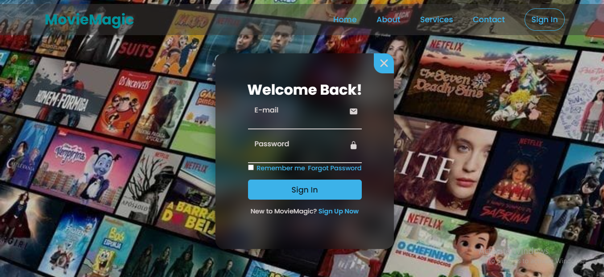
Figure 10:Login Page

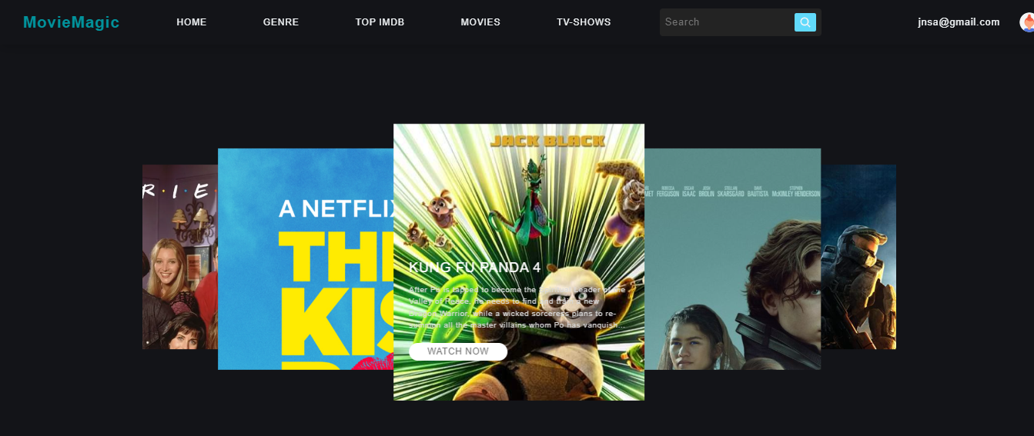
Figure 11:Homepage 1
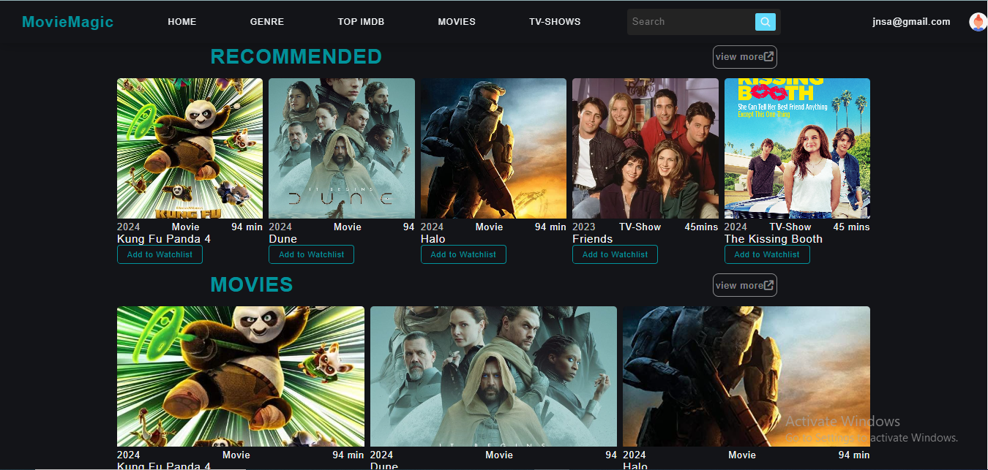
Figure 12:Homepage 2

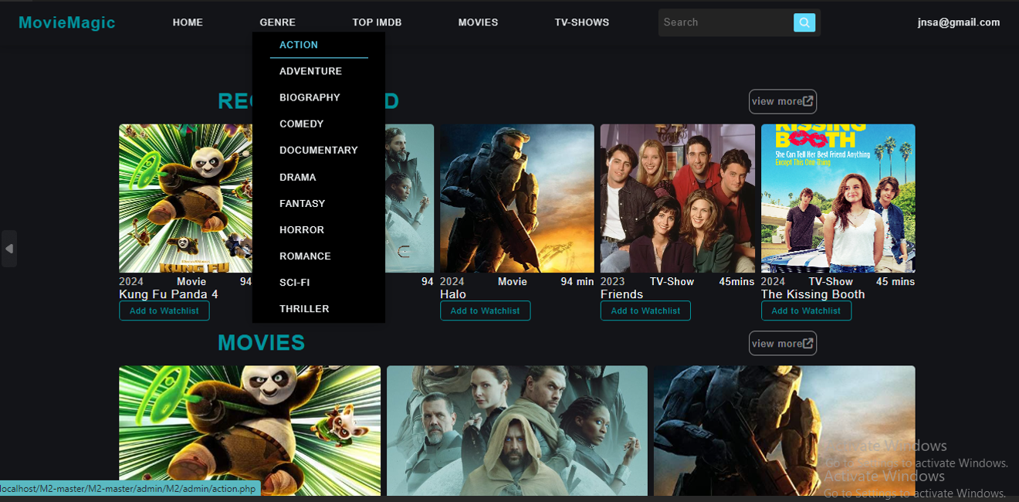

Figure 13:Dropdown option
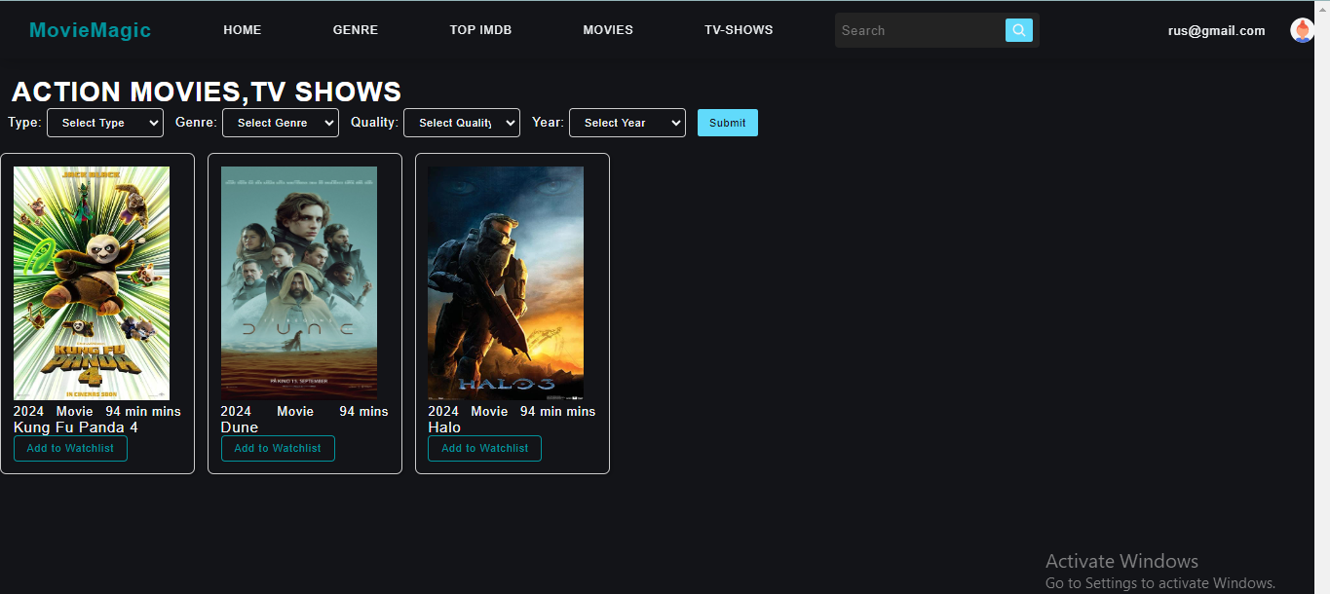
Figure 14:Action Page



Figure 15:TV Shows Page
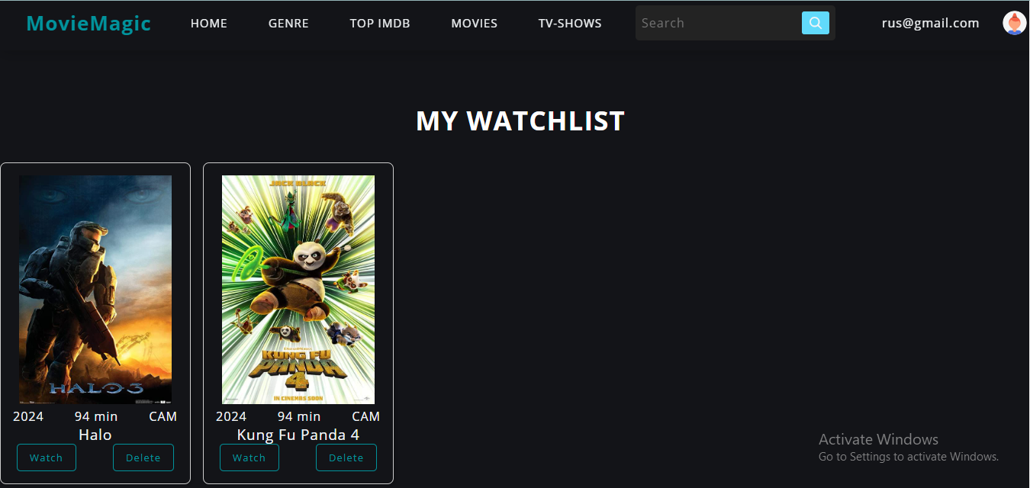
Figure 16:Watchlist

